Data Science Project Proposal
Exploratory Data Analysis of Popular Anime
Kaggle link
Project Idea
I will analyse a Kaggle dataset containing over 22,000 popular anime titles. The dataset includes information such as title, genres, average score, number of ratings, studio, type, episode count, and release date. The aim is to explore patterns in anime data and present the findings using charts and summary statistics.
Dataset
I will use the Top Popular Anime dataset from Kaggle. Each row in the dataset is one anime, and the main variable I will focus on is score, which is the average rating given by users on MyAnimeList. The dataset also includes columns such as genres, type, episodes, duration_per_ep, studios, scored_by, and members.
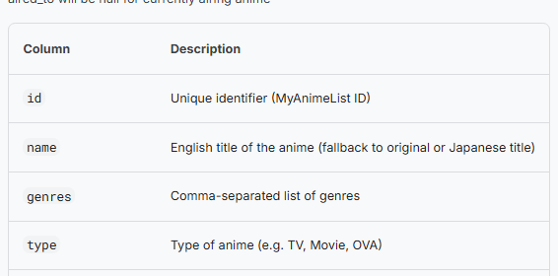
Questions:
- Which genres are most common in the dataset?
- What are the highest-rated anime?
- Which anime studios have produced the most titles?
- Which genres and anime types have the highest average ratings?
- How has the number of anime releases changed over time?
- Is anime with more ratings generally scored more highly?

Technologies:
- Python
- Jupyter Notebook
- pandas and NumPy
- Matplotlib and Seaborn
- Kaggle dataset
I will use Python in a Jupyter Notebook. The main libraries will be pandas and NumPy for loading and cleaning the data, and Matplotlib and Seaborn for graphs and visualisations.
A question on machine learning:
Is machine learning required for the portfolio project, or is exploratory data analysis and visualisation enough for the first version?
Initial model: No model; exploratory data analysis will be used first.
Possible later model: Linear regression or more (?).

